Ideation Phase

**PROBLEM STATEMENT**

|  |  |
| --- | --- |
| Date | 16 October 2022 |
| Team ID | PNT2022TMID17225 |
| Project Name | Project -IOT Based Safety Gadget for Child Safety Monitoring and Notification |
| Maximum Marks | 2 Marks |

**Customer Problem Statement:**

The child needs to be monitored even when the parents are distracted. A momentary lack in parental supervision should be combated with an appropriate IT solution in context. The child needs to stay generally within the line of sight. It is necessary for the proposed system to alert the parents when the child walks too far away and outside the circle of safety‟ (generally the parents‟ line of vision), even if the parents are distracted. If the child does go missing, the aid of technology can increase efficiency and decrease the time necessary to locate the child. The child needs to be located, only at the will of the authorized persons (the parents). Once there is data available about the location of the missing child, this data needs to be displayed as information that the parents can easily understand and use.

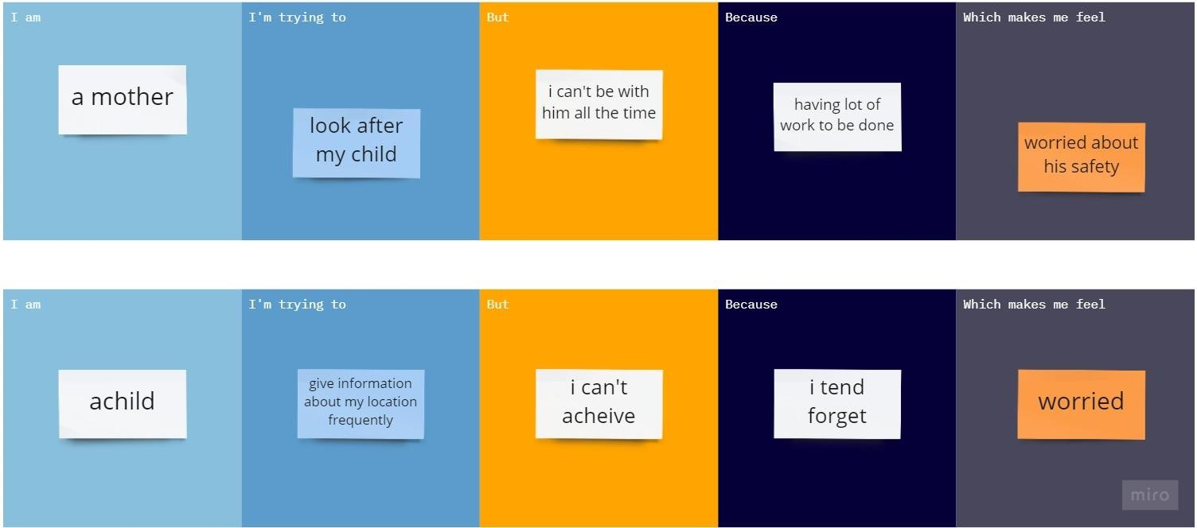

|  |  |  |  |  |  |
| --- | --- | --- | --- | --- | --- |
| **Problem Statement (PS)** | **I am (Customer)** | **I’m trying to** | **But** | **Because** | **Which makes me feel** |
| PS-1 | Mother | Look after my child | I can’t be with him | Having lots of work to be done | Worried about safety provided prior on him |
| PS-2 | child | Give information about my location  frequently | I can’t achieve | I | Feel worried |